**Jackson Kerchis – Happiness Studies**

**Money & Happiness: Economics Research on Happiness**

**White Paper – March 2022**

*Can money buy happiness?*

*How much does income matter? Should I choose time or money? Is GDP the best measure for progress?*

*To answer such questions, we turn to the economics of happiness.*

I finished my economics major in two years and decided to study happiness. I had not thought these two interests would converge. But it turns out economics offers a useful lens through which to investigate happiness. Further, our economic system is somewhat analogous to the operating system for society. It provides many of the norms, rules, and values in which our lives are embedded. So, economics is inextricably linked to happiness.

In this paper I discuss significant findings at the intersection of happiness and economics. Consider this a research primer or informal literature review. You should treat this as a reference resource: skim, jump around, or read it through.

I begin with happiness at the individual level: the relationship between income and happiness and how to use money to most effectively generate happiness. I then explore the group or macro level: the relationship between economic growth and happiness. This includes the strange case of the Unites States where enormous economic growth has not generated increased happiness.

# (Part I) Economics x Happiness: Individuals

## Income and Happiness

*What is the relationship between individual (household) income and happiness?*

Likely the most famous (and misunderstood) study on happiness and income is Kahneman and Deaton’s 2010 paper: “High income improves evaluation of life but not emotional well-being” ([reference](https://doi.org/10.1073/pnas.1011492107)). It is often cited to say that beyond $75,000 per year income does not increase happiness.

The research is more nuanced than that.

As the title suggests, there are different ways to understand happiness. You can be happy *with* your life as opposed to happy *in* your life. Life satisfaction (with your life) is a more intellectual process of stepping back and evaluating your life as a whole. Emotional wellbeing or affect is the actual experience of positive emotion. It is possible to *feel* good while dissatisfied with life. And it is possible to be satisfied with life while feeling bad.

The relationship between income and happiness is different based on the type of happiness considered. See the graph below. The authors break up emotional, experienced happiness into positive affect (feeling good), not blue (absence of feeling bad), and stress free. They use a Cantril Ladder (“Ladder”) to assess life satisfaction. The Cantril Ladder asks you to rate your life as a rung on a ladder where 0 is the worst life possible and 10 is the best.

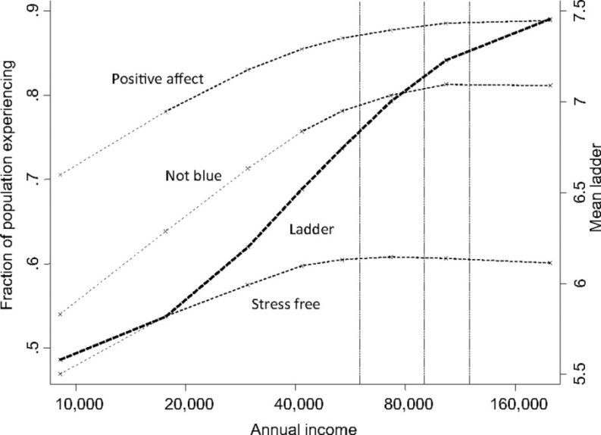

Kahneman & Deaton 2010

As income increases, its effects on happiness generally diminish. This makes some intuitive sense (think diminishing marginal utility). The more money you make the less useful each dollar is. $10,000 is a big deal to the average person but not to Jeff Bezos.

This pattern applies primarily to experienced happiness. This is known as satiation point. Like eating – at some point you begin to get full and additional food is not as satisfying. At about $60,000 in household income ($77,000 in 2022) you approach a satiation point for stress. Living paycheck to paycheck and facing financial uncertainty is stressful. Once you know your needs are met, you can relax. The other measures of emotional wellbeing level out around $75,000 ($97,000 in 2022). It is important to note that these are averages and the actual satiation point varies widely based on cost of living, family size, etc.

Life evaluation, on the other hand, keeps rising with income. This implies that we often use our income as a shortcut to determine how we are doing in life. This speaks to the role of cultural conditioning in shaping our own sense of happiness (a topic discussed in the next section).

To summarize this first study - once you have enough money to be comfortable, additional income will likely have minimal effect on your experience of happiness (e.g. positive emotion) but it will improve your evaluation of your life.

There has been debate over this finding in recent years. The most well-known example is Matt Killingsworth’s aptly named “Experienced well-being rises with income, even above $75,000 per year” ([reference](https://doi.org/10.1073/pnas.2016976118)). Killingsworth devised a clever (and more reliable) way to measure happiness. He created an app that prompts people several times per day to rate their happiness. This app captured data from over 33,000 working professionals in the US. He used this data to create a logarithmic description of the relationship between income and happiness. And found that there was no “satiation point” (below).

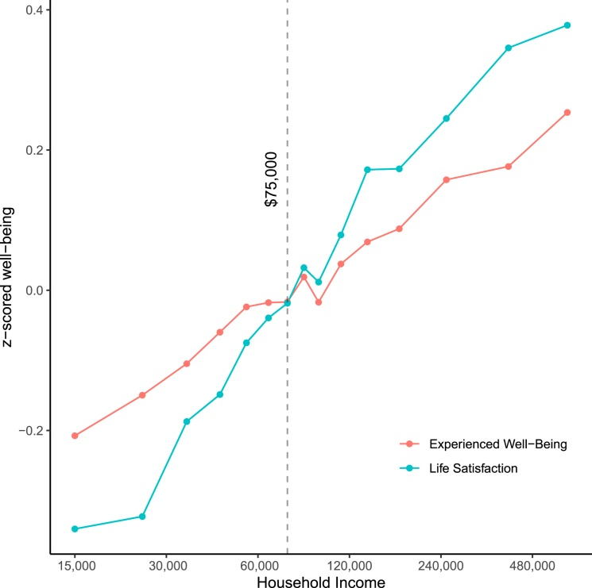

Killingsworth 2021

Killingsworth’s research is rigorous and sound. Nonetheless, it is important to consider the practicality of a logarithmic scale. Yale Professor Laurie Santos explains that if you actually plot this, it implies that if you “change your income from $100,000 to $600,000 your happiness goes from like a 64 to a 65”.

The use of the logarithmic scale can obscure the real effect of diminishing returns. It also does not capture relative tradeoffs. That is not a criticism of Killingsworth’s work, as it is outside the scope of what he studied. But for practical purposes you can imagine working an additional 20 hours per week for a 150% increase in income is probably not as efficient in increasing happiness as investing a few hours towards additional sleep, exercise, or social interaction.

It seems absolute income is the more practical treatment here. If you are making $97,000 per year and someone offers to double it. By all means say yes. But on the margin there are higher-return ways to allocate time beyond the pursuit of additional income.

*There are other factors that influence the relationship between income and happiness.*

These first two studies took a straightforward look at income and happiness. But the income-happiness relationship is more complicated than meets the eye. Relative income, changes in income, and focusing on income are much more important in influencing your happiness than income itself.

Think of the cognitive processes that go into assessing your happiness in the context of income. What research finds is that it is hard to assess our situation in abstract. We need standards of comparison: either across time or other people.

A 1996 paper by Clark and Oswald and a 2005 paper by Luttmer show that your income level in relation to your peer group is more important than your absolute income ([reference](https://www.sciencedirect.com/science/article/abs/pii/0047272795015647), [reference](https://academic.oup.com/qje/article-abstract/120/3/963/1841496)). For instance when it comes to happiness you are likely to be happier making say $80,000 surrounded by folks making $40,000 than you would be making $100,000 surrounded by folks making $150,000. This counterintuitive observation speaks to the role social norms and anchoring.

Additionally, Kahneman, Krueger, Schkade, Schwarz, and Stone found that changes in income elicit strong emotional responses but the long-term effects on happiness are small ([reference](http://www.morgenkommichspaeterrein.de/ressources/download/125krueger.pdf)). Imagine your employer cuts your salary by 1%. You would be upset. But this would amount to an immaterial per year change after taxes. In the long run it would not have much effect.

This same paper calls attention to the focusing illusion. This illusion occurs when we are asked to assess our happiness in the context of one specific thing. For example, when college students are asked about their happiness levels and about how many dates they have gone on in the last month there is no correlation. But when the questions are reversed – there is a 0.66 correlation. In other words, students focused on dating success as a standard to judge their happiness. So studies that directly examine the effect of one variable on happiness are likely to overstate the effect due to the focusing illusion.

*Summary: What is the relationship between income and happiness? Does how much you make matter for happiness? The answer is yes, but it is a long story.*

*There are diminishing returns between absolute income and happiness. When your income is low, additional income makes you happier. But once you are well off, the impact is rather minimal. It will only increase your evaluation of life. How much you earn compared to others, changes in what you earn, and if you focus on what you earn before you think about your happiness matter more than how much you actually earn.*

## Time or Money?

*What does the tradeoff between time and money have to do with happiness?*

Accompanying this discussion of income and happiness we have to consider the old adage that time is money (and in some ways money is time). Given the digital, globalized world economy -- every moment of time has some implicit dollar value. I could earn $30 per hour as an online tutor during the 8 hours I choose to spend sleeping. Spending $5,000 on a car equates to living expenses that I could have used to not work for 2 months.

There is always going to be some tension or tradeoff between time and money. Common sense and folk wisdom urge us to prioritize time (“you can’t buy time”). Although usually we do not listen… What does the research say?

The general consensus is time affluence is a better recipe for happiness than financial affluence. Tim Kasser and Kennon Sheldon’s 2009 paper provides empirical evidence that time affluence positively correlates with subjective wellbeing while holding material affluence constant ([reference](https://psycnet.apa.org/record/2009-01846-007)). At any given income level – you will be happier if you prioritize time over money.

A similar insight is found in Whillans and Dunn’s 2019 paper “Valuing Time Over Money Predicts Happiness After a Major Life Transition…” ([reference](https://www.hbs.edu/ris/Publication%20Files/19-048_a3814174-e598-46af-ae70-0c81cdffdb9e.pdf)). They took a sample of graduating college seniors and measured how they value time versus money. They did this by asking participants who they were more like between two hypothetical people (below).

*Tina values her time more than her money. She is willing to sacrifice her money to have more time. For example, Tina would rather work fewer hours and make less money, than work more hours and make more money.*

*Maggie values her money more than her time. She is willing to sacrifice her time to have more money. For example, Maggie would rather work more hours and make more money, than work fewer hours and have more time.*

*Are you more like Tina or Maggie?*

They followed up with participants one year later - after the majority had started their careers. They measured their subjective wellbeing. They found that those who valued time over money had higher wellbeing one year later.

What’s more, they controlled for other factors (such as initial happiness level) and found that improvements in wellbeing were at least partially explained by one’s preference for time over money at the time of the initial sample. So one’s preference for time had a meaningful positive effect on his or her happiness later on.

A final conclusion comes from Herschfield, Mogilner, and Barnea in a 2016 paper titled “People Who Choose Time Over Money Are Happier” ([reference](https://doi.org/10.1177%2F1948550616649239)). It includes the following lines in the abstract:

*Across studies, we asked thousands of Americans whether they would prefer more money or more time. Although the majority of people chose more money, choosing more time was associated with greater happiness—even controlling for existing levels of available time and money.*

*Summary: In making tradeoffs between time and money it is generally best (in terms of happiness) to prioritize time.*

## How to Spend for Happiness

*Does the income-happiness relationship depend upon how we spend?*

There’s more to the money-happiness story. How you spend your money (and time) matters most. A discussion of how to best spend your time would be an entire positive psychology book. So I will focus on the economics research into how to spend money for more happiness.

*“Money doesn’t buy happiness; it buys an opportunity for happiness.” – Dan Gilbert, Harvard psychologist*

1. **Spend on others.**

Harvard’s Michael Norton is a leading happiness-money researcher. He says that money *can* buy happiness. The key is prosocial spending that benefits not just you, but other people too.

In his most famous study ([explained here](https://www.ted.com/talks/michael_norton_how_to_buy_happiness?language=en)), he and his team asked students if they would be part of an experiment. Their self-reported happiness was measured. Then they were given an envelope with $5 or $20 dollars. They were instructed to either spend it on themselves or on someone else.

You might think that the spend-on-others group would see about the same change in happiness as the other group, or perhaps they would be frustrated that they were forced to spend on someone else. In reality, the spend-on-others group reported higher levels of happiness that persisted for several days.

The researchers wondered if this pattern would persist for higher dollar value exchanges. So they replicated the study in Ethiopia where $20 equates to several hundred dollars. They found the same pattern. In line with their other research ([reference](https://www.hbs.edu/ris/Publication%20Files/Dunn%20Aknin%20%20Norton%20-2014%20CD_bfccfc43-4139-476a-904b-ebcf855ab7c3.pdf)), this appears to be a human universal.

“Prosocial spending” or spending to benefit others makes you happier (there are even biomarkers that indicate this).

1. **Spend on experiences.**

Van Boven and Gilovich’s 2003 paper - “To Do or to Have? That is the Question” ([reference](https://psycnet.apa.org/doi/10.1037/0022-3514.85.6.1193)) shows that spending on experiences translates to greater happiness. Here are three lines from the abstract that report the survey and experimental findings:

*“Do experiences make people happier than material possessions? In two surveys, respondents from various demographic groups indicated that experiential purchases-those made with the primary intention of acquiring a life experience--made them happier than material purchases. In a follow-up laboratory experiment, participants experienced more positive feelings after pondering an experiential purchase than after pondering a material purchase.”*

They go on to explore why it is that experiences yield more happiness.

They suggest that experiences allow for positive reinterpretations (savoring the memory); are more meaningful parts of one’s identity; and support better social interactions. This last point is interesting: they found that if you discussed a material purchase, as opposed to an experience purchase, you were rated as less well-adjusted and enjoyable.

1. **Spend to avoid save time and avoid pain (rather than get pleasure).**

If you analyze your spending, there is usually one of two motives behind it. You want to avoid something (suffering, stress, hassle) or get something (pleasure, joy, status). If you pay for a cleaning service or financial management app it’s likely the first category: to avoid stuff you do not want to do. If you buy a snack or a luxury car it is likely to get pleasure.

Research finds that you are usually happier if you spend money to save time on unpleasant activities as opposed to seeking pleasure. In their book, *Happy* *Money*, Dunn and Norton use the example of outsourcing things you hate doing such as hiring a cleaning service. Such investments generate more happiness than similar sized investments in the pursuit of pleasure.

According to Whillans, Dunn, Smeets, Bekkers, and Norton’s 2007 paper ([reference](https://doi.org/10.1073/pnas.1706541114)): “Surveys of large, diverse samples from four countries reveal that spending money on time-saving services is linked to greater life satisfaction. To establish causality, we show that working adults report greater happiness after spending money on a time-saving purchase than on a material purchase.”

*Summary: For greater returns to happiness it is best to spend on others, spend on experiences, and spend to save time and reduce unpleasantries.*

***Summary of Economics x Happiness: Individuals***

*As individuals, we have a rather complicated relationship with income. When viewed in absolute terms (rather than logarithmic) additional income results in more experienced happiness but with diminishing returns. In other words, the more we have the less it affects our happiness. Additional income does however continue to make us rate our lives as better even if the raw experience of happiness is only minimally impacted.*

*What’s more, income effects depends largely on recent changes in income, our income in comparison to our peer groups, and how much we have been prompted to weigh income in our determination of our happiness (focusing illusion).*

*Generally, prioritizing time wealth over financial wealth is optimal for happiness. And how we spend is critical. Money can buy happiness - if we know how to spend it. Spending to benefit others, spending on experiences, and spending to save time and hassle are ideal for happiness.*

# (Part II) Economics x Happiness: Macro Level

## Economic Development and Happiness

*What is the relationship between economic development and happiness?*

Perhaps the most important topic at the intersection of economics and happiness is the relationship between economic development and happiness. Is economic prosperity the source of happiness? Does material progress and growth make people happier?

The well-known Easterlin Paradox is the starting point for this discussion. In a 1971 paper Richard Easterlin found that at a point in time, happiness varies with income among and within nations, but over time it does not increase as income grows. So, as the economy expands and contracts, income levels and corresponding happiness will fluctuate. But over the long run as the economy steadily grows, there is not a corresponding increase in happiness. This ties back (perhaps) to the observation that changes in individual income illicit strong responses but over time the impact of income on happiness is rather minimal – especially once one’s needs are met.

Many well known researchers have disputed Easterlin’s claim (see Wolfers and Sacks 2010 and several others at [brookings.edu](http://brookings.edu/)). They say there is overwhelming statistical evidence that both life satisfaction and economic development have steadily risen together across most all countries. Particular examples include Latin America and Europe.

Without plunging too far into this debate, it is worth sharing a reminder that correlation does not equal causation. Look at two statistical realities: (1) richer countries generally have higher levels of life satisfaction and (2) over the last several decades economic status and life satisfaction have steadily risen in many countries.

Now, does that mean that economic growth *caused*increased happiness? It seems that way, but it is not that simple. For instance, many of the transition economies providing this data transformed from communist or socialist systems to democratic ones. Was it the economic growth or the political changes that increased happiness?

Many countries saw improvements in workplace rights, civil liberties, and social support programs – perhaps those, and not economic growth outright, are driving more happiness? Finally, economic growth has downstream effects such as more access to technology, educational opportunities, and leisure time. Perhaps these consequences of growth, and not the growth itself, produce happiness.

Take the hypothetical comparison between countries A and B. Country A has a 300% increase in GDP. The majority of this value is captured by a small percentage of the country with the most capital, there is little investment in public benefit programs (e.g. healthcare and education), and folks work more instead of less due to intense competition. Country B has the same growth in GDP but the value is more evenly distributed, there is generous investment in the public good, and citizens have protected leisure time and reduced work pressures.

It is probable that country B experiences increased happiness while country A remains relatively unchanged. This point is summarized nicely in Berkeley’s Beyond GDP: Economics and Happiness review ([reference](https://econreview.berkeley.edu/beyond-gdp-economics-and-happiness/)).

The authors explain that changes in GDP per capita itself will cause minimal change in happiness. However when GDP per capita is included with other variables, it will explain nearly 75% of variance in happiness. These variables include social support, life expectancy, freedom, generosity, and lack of corruption.

Just increasing GDP with no concern for how it is spent, provides diminishing returns to societal happiness. In the USA, for instance, GDP has tripled since the 1970s but happiness has remained flat (a case I discuss later).

*Summary: In the short term, economic changes have significant effects on happiness. In the long term, this relationship is less certain. Generally, economic development equates to rising happiness. But this does not guarantee a causal relationship. It is uncertain the extent to which economic growth in itself is causes increased happiness. It is likely that how this additional economic value is used is what really matters for happiness.*

## The Strange Case of the Unites States

*Why hasn’t economic abundance increased happiness in the US?*

The US is an economic superpower. But why have we failed to translate this into greater happiness?

We ought to give credit where it is due. The US is typically near the top of the list of happiest countries. We usually fall between 17-22 near the UK, France, Belgium and Ireland. We trail most all Scandinavia, Costa Rica, Canada, Australia, and several other northern European countries.

In a graph of GDP per capita versus happiness, we are near the upper right quadrant indicating that we are relatively high in both. However, as you can see in this chart, economic development is not everything – see India, Japan, and the US ([reference](https://www.economist.com/graphic-detail/2019/03/21/economic-growth-does-not-guarantee-rising-happiness)).

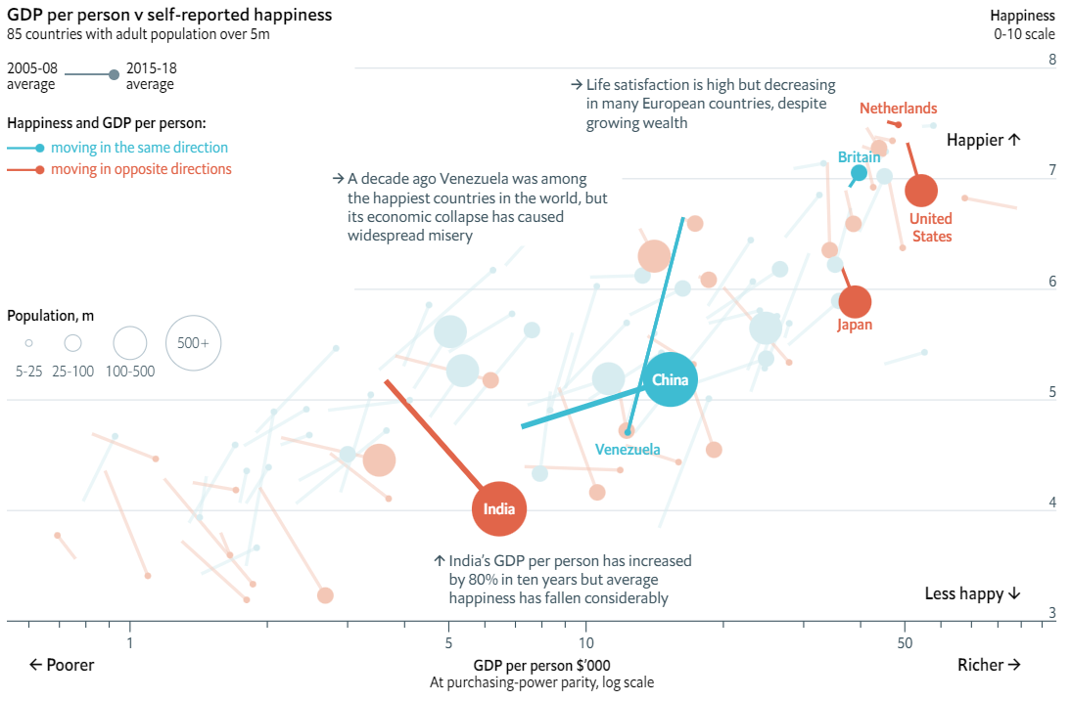

An even clearer illustration comes from Easterlin and Angelescu’s 2007 paper below ([reference](https://www.researchgate.net/figure/A-The-American-paradox-Happiness-and-Real-GDP-per-Capita-United-States-1972-2002-Taken_fig7_49130644)). We see that in the US, GDP per capita has almost tripled while happiness is flat.

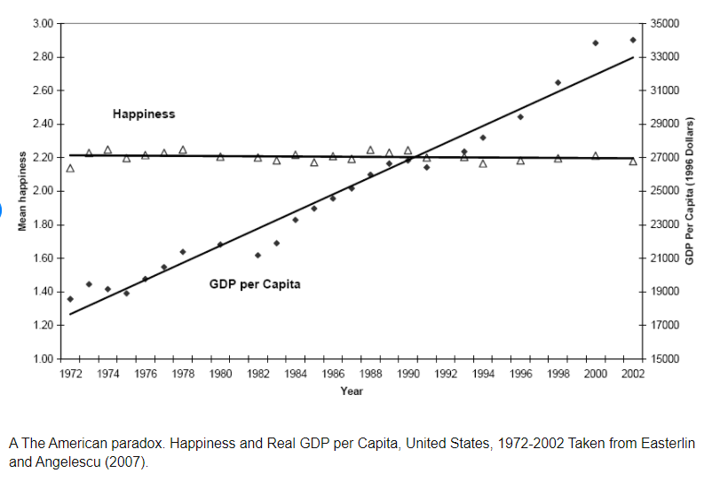

There is criticism of Easterlin’s work (mentioned earlier) but generally this pattern has been confirmed in the case of the US ([reference](https://worldhappiness.report/ed/2019/the-sad-state-of-happiness-in-the-united-states-and-the-role-of-digital-media/)). We are all much richer. But we are not much happier. Why is that? There are five factors in the development of the US that can be linked to reducing or inhibiting happiness.

**Wealth Distribution**

The US has one of the most unequal distributions of economic growth. There is a wealth of literature confirming this observation and analyzing it. To keep things short, from 1979 to 2007 after tax income of the top 1% grew about 275%. The bottom 20% of Americans saw about 20% growth. That data comes from the Congressional Budget Office ([reference](https://www.cbo.gov/topics/income-distribution)).

Another example of this pattern comes from the Economic Policy Institute: in the 1980s CEO pay averaged about 30x that of the typical worker. Now the multiplier is more like 350x ([reference](https://www.epi.org/publication/ceo-pay-in-2020/)). From 1978 to 2018 CEO compensation grew 940% while the typical worker’s increased 12% ([reference](https://www.epi.org/research/economic-inequality/)).

Perhaps more discouraging is a study from Krugman in the *American* *Prospect* in 2019 that found that about half of the families in the top or bottom quintile of income distribution are still there 10 years later. Only about 4.5% rose from bottom to top or fell from top to bottom. In other words, economic mobility is largely an illusion.

Oishi, Kesebir and Diener in a 2011 paper on income inequality and happiness found Americans were happier in years with lower income inequality and less happy in years when it was higher ([reference](https://journals.sagepub.com/doi/abs/10.1177/0956797611417262)). This is due to perceptions of fairness and social trust. This is in line with other research from those like Berg and Veenhoven that find imbalances in wealth distribution predict unhappiness.

**Corruption and Mistrust**

Corruption reduces happiness for high income countries according to a 2014 paper by Arvin and Lew ([reference](https://www.emerald.com/insight/content/doi/10.1108/JES-02-2013-0024/full/html#:~:text=As%20a%20result%2C%20corruption%20declines,with%20lower%20levels%20of%20happiness.)). Political trust and income on the national level play an important role in personal life satisfaction. Clench-Aas and Holte in a 2021 paper write that “politicians who want to enhance their population's personal life satisfaction, should raise the levels of trust in their electorate” ([reference](https://www.ncbi.nlm.nih.gov/pmc/articles/PMC8005631/)).

General distrust and cynicism with respect to social and political institutions has been on the rise in the US. In 2019 Pew Research Center published a thorough report on distrust in America, shown below ([reference](https://www.pewresearch.org/politics/2019/07/22/trust-and-distrust-in-america/)).

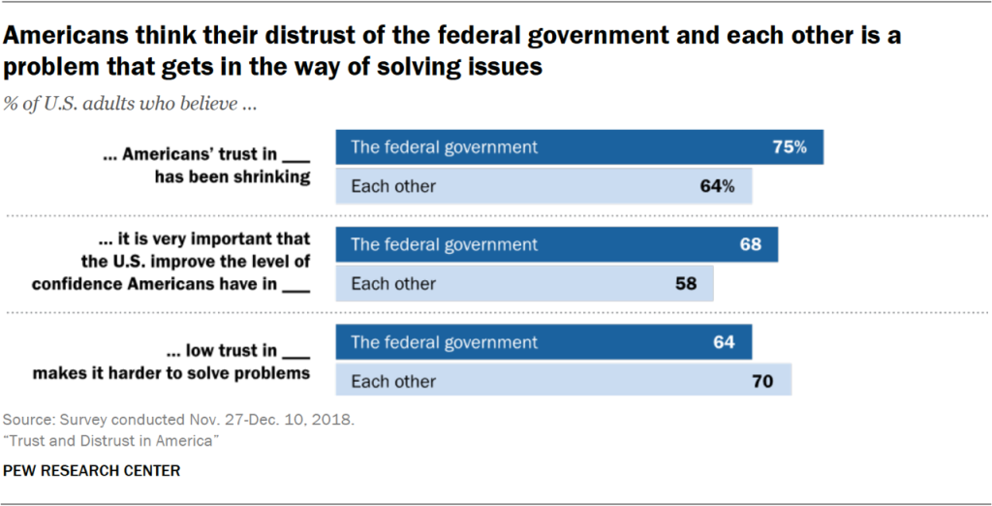

The General Social Survey and American National Election Survey shows that during the 1970s about 50% of Americans said that most people can be trusted. Now about 33% of people say that ([reference](https://sda.berkeley.edu/archive.htm)). What’s more, the US is the only first world democracy in which there has been a major decline in social trust. From 1998 to 2014, social trust increased in Sweden by 10%, in Australia by 14%, and in Germany by 10%. This comes from *Trust in a Polarized* *Age* by Vallier.

Unfortunately, there is good reason for this distrust in modern America’s institutions – particularly in the political sphere. Stephen Walt – a world renowned political theorist and Harvard Professor - cites examples in the Trump administration, the 2008 financial crisis, the failure of the Boeing 737 MAX, and the 2019 college admissions bribery scandal. Haphazard government responses to COVID-19 (on both sides) have furthered this trend. As of 2020 the US was at its highest level of perceived corruption in over 10 years ([reference](https://www.transparency.org/en/press/2020-corruption-perceptions-index-reveals-widespread-corruption-is-weakening-covid-19-response-threatening-global-recovery)).

We must also consider the proliferation of lobbying. It is likely playing a role in undermining political trust. OpenSecrets.org is a national nonprofit tracking campaign finance and lobbying in the US. Their data shows that total spending on lobbying has grown from $1.44 billion in 1998 to $3.53 billion in 2020. Lobbying played a significant role in shaping political outcomes in international relations, post financial crisis regulation, and COVID-19 response. Some 65-75% of lobbyists are former government employees ([reference](https://www.opensecrets.org/federal-lobbying/industries/summary?cycle=2019&id=F07)).

The proliferation of lobbying and general dysfunction of the political system in the US have increased social and political distrust. The feeling of mistrust and the perception of corruption are shown to reduce happiness. This is a factor that explains the US situation.

**Trends in Values**

There are two disturbing trends in US values that explain why happiness has stagnated while economic growth has flourished. First, US citizens increasingly value financial status over other life factors. In the American Freshman Surveys “developing a meaningful life philosophy” traded places with “being very well off financially”.

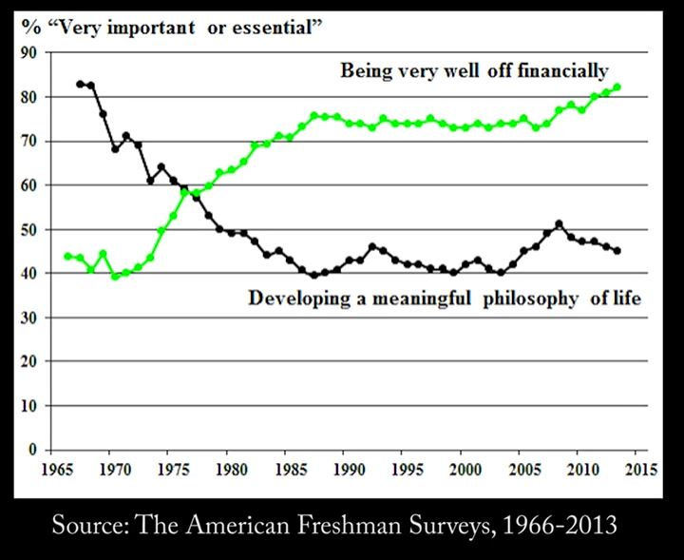

This is not the only explanatory trend at work. The average American’s number of close friends has decreased over time. A 2021 study published by the Survey Center on American Life ([reference](https://www.americansurveycenter.org/research/the-state-of-american-friendship-change-challenges-and-loss/)) reports that Americans have fewer close friendships than they once did, talk to their friends less often, and rely less on their friends for support. 49% of Americans report having fewer than three close friends. This percentage has almost doubled since 1990 when only 27% of Americans had 3 or fewer close friends. At that time, one third of people reported having 10+ close friends, compared to 13% today.

It is difficult to isolate a specific causal variable for these trends. It seems that professional and financial concerns may be crowding out time and cognitive energy that might otherwise be invested in pursuing meaningful activities or social connection. Whatever the cause, these trends in cultural values contribute to stunting happiness in the US.

**Consumer Culture**

Anthropologist James Suzman has spent several years investigating why material affluence has not led to abundant happiness. In a fascinating interview ([here](https://www.nytimes.com/2021/06/29/podcasts/transcript-ezra-klein-interviews-james-suzman.html)) he explains that our consumer economy today is not driven by what we need. It is driven by what we want. It is driven by how our culture intentionally regulates and encourages wants.

Suzman claims that in the first world, we have solved the problem of scarcity. Now we have to manufacture a sense of scarcity to keep our economic engine going. As he says “we’ve developed [an economic] machine, not for ending our wants, not for fulfilling them, but for generating new ones, new needs, new desires, new forms of status competition”.

Advertising and the relentless promotion of consumption puts us on a never ending treadmill of increasing wants which are never quite satisfied. For in a consumption-based economy, instilling a sense of unlimited desire is necessary to keep the economy moving forward.

DeAngelis writes more on this in her 2004 paper explaining how materialistic values undermine happiness ([reference](https://www.apa.org/monitor/jun04/discontents)). This is also part of the explanation presented by David Myers in his widely read book: *The American Paradox* and Tim Kasser in *The High Price of Materialism.*

The current consensus of social and positive psychology sheds light on this economic concern. The increasing zeal of our materialistic values and consumer culture have left many Americans unhappy.

**Work-life Balance**

The US has amongst the worst work-life balance of any leading nation (see OECD’s Better Life Index). A Brazilian friend of mine said when describing the most surprising thing about his time in America that “in Brazil you work to live and in America you live to work.”

A Gallup poll found that the average American work day has increased by some 90 minutes in the last 20 years. And in terms of work-life balance policy, the US is virtually the only first world country that does not legally mandate any paid holidays or vacation time. Canada is the next closest, guaranteeing a total of only 19 days ([reference](https://cepr.net/images/stories/reports/no-vacation-nation-2019-05.pdf)).

The increased work-life *imbalance* and lack of policy to support the workforce is yet another explanatory variable in the strange case of the US.

*Summary: There are several factors linked to inhibiting happiness at the population level that are readily observable in the US. These include distrust in social and political institutions, income inequality, the psychologically damaging effects of consumer culture, and a tendency to value increased work and financial status over social connection, meaning, and leisure. These are likely explanations for the strange case of the US.*

***Summary of Economics x Happiness: Macro Level***

*In closing our discussion of economics and happiness at the group level, it is uncertain - but likely - that economic growth does not guarantee more happiness. While there is a pattern of economic growth and happiness increasing over time – how that growth is used seems to matter more than the growth itself. The strange case of the US exemplifies this point.*

# Author’s Note:

I hope you’ve enjoyed this read on Economics and Happiness. You can keep up with me via email at [happinessmajor.com/newsletter](http://www.happinessmajor.com/newsletter) and browse my other writings and teachings on social media: @jacksonkerchis.

If you want to talk happiness (even if you disagree with me) or you have an idea for how to create a happier world – I’m always in to connect!

Wishing you happiness –

Jackson Kerchis

